Study about the protective effect of allicin (Thiosulfanate) against testicular toxicity of oxidant agent (zinc oxide) in male rats

Dr. Sanna abadi habeeb* Dr. Nawras noori bashboosh**
A.Res. Israa samiermhana***
Faculty of Science/ University of Kufa

Abstract:
The aim of this study is to investigate the protective role of the allicin (thiosulfanate) on the histological alterations of testes induced by oxidant agent zinc oxide (ZnO). The first group of the rats was negative control group. The second treatment groups were received 5o ppm of allicin, the third by ZnO the fourth group treated with allicin +ZnO, All treated doses were given orally by gastric intubation with allicin and ZnO by injection, the experiment was continued daily for 30 days. Due to experimental intoxication with ZnO, the microscopic examination for the testes in rats revealed numerous histological lesions in the seminiferous tubules and the interstitial tissue. In contrast, the histopathologic changes of testes were partially reversed by treatment with allicin extraction and the testes appeared with nearly normal structure. It may be concluded that allicin revealed protective effect against the reproductive toxicity of ZnO.
Key words: allicn, zinc oxide, testes, seminiferous tubules, rats.

دراسة حول التاثير الوقائي للاليسين (الثايوسولفانيت) ضد التغيرات النسجية لعامل الاكسدة (اوكسيد الزنك) في خصى ذكور الجرذان

الخلاصة:
ان الهدف من هذه الدراسة هو تقصي الدور الوقائي للمادة الفعالة في الثوم وهي الاليسين (الثايوسولفانيت) ضد التغيرات النسجية في خصى الجرذ المستحثة عن طريق عامل الاكسدة (اوكسيد الزنك)، تم تخصيص المجموعة الأولى من الجرذان كمجموعة سيطرة (المجموعة السالبة), أما المجاميع الثلاثة المعاملة فقد اعطيت الاولى مادة الاليسين والثانية اوكسيد الزنك والثالثة مزيج من الاليسين واوكسيد الزنك واستمر الاعطاء يوميا لمدة ثلاثون يوما ً, بسبب السمية التجريبية من جراء المعاملة بأوكسيد الزنك, بينَّ الفحص المجهري للخصى حدوث أضرار نسجية عدة في النبيبات المنوية وفي النسيج البيني للخصية، بالمقابل, فإن التغيرات النسجية-المرضية للخصى قد تحسنت جزئيا من جراء المعالجة باللسين وظهرت الخصى قريبة من تركيبها الطبيعي، لذا يمكن الاستنتاج بأن الالسين او الثايوسالفيتيت قد أظهر تأثيرا وقائيا ضد السمية التكاثرية لأوكسيد الزنك.

INTRODUCTION
Allium sativum (Garlic Family Amaryllidaceae) is one of the most plants that using in the researches ,it is an important component of the diet so it commonly used herb for both culinary (as a flavor enhancer) and medicinal purposes (1). In present time, there is a much interest for using medical plants due to their medicinal characteristics to depress the dangerous of diseases (2). Allium sativum has abundant amount of antioxidants, flavonoids and it is a rich in bioactive organosulfur compounds such as allicin, alliin, diallyl disulfide, diallyl trisulfide, S-allylcysteine and S-allyl mercaptocysteine. (3,4) . Thiosulfinates are the chief bioactive compound present in aqueous garlic extract have biological effects (5). recently, the researchers has been attending to treat diseases by replacing chemical drugs with some natural plant components (6). Once , it demonstrated that oral administration of garlic acts as insulin which lower blood sugar levels in diabetic patients (7) . Allium sativum preparations are known for their cardioprotective effects (8,9) and reduce the risk of atherosclerosis (5) , with ability to lower blood pressure (10) in people with high blood pressure and lower lipid levels so it have been used for the treatment of cardiovascular diseases and hypertension ; (11 , 12) , hypercholesterolemia and diabetes mellitus (13, 14) . as well as for bacterial infection due to the sensitive of microorganisms including, bacteria, fungi, protozoa and viruses to crushed Allium sativum preparations (15,16). Allium sativum and its bioactive constituents have been used also for the protection against many types of cancers; (17) , increasing of immunity (18,19) , reduce the risk of inflammation (20) as well as for protection against neurotoxicity (21) and oxidative stress (OS) (22) in experimental animals and humans. Infertility is the most common health problem in couple life and approximately about 30 % of this problem is attributed to male factors (23). Several factors can effect on spermatogenesis and decrease sperm quantity and quality leading to lower the sex fertility. a lot of sicknesses and cases such as coronary heart diseases, diabetes mellitus, chronic liver diseases, chronic smoking, alcohol intake, prolonged exposure insecticide contaminants, air pollutants and insufficient vitamins intake have harmful effects on spermatogenesis (24-27). On the other hand, the intake of natural antioxidants , vitamins E , C and others etc. can be protect sperm DNA and other cells from oxidative stress (OS) in rats (28-30). Zn is one of metals that found in the body in trace amounts and it will be essential for development, growth and health, but these elements may produce toxic effects following excessive exposure, due to be at high levels (31).Enhanced generation of reactive oxygen species (ROS) can overwhelm cells' intrinsic antioxidant defenses, and result in "oxidative stress". Cells under the effect of OS exposed various injurious caused by ROS effects of lipids, proteins and DNA at these cells, so that the naturally or synthetically antioxidants may play an important role in diminishing some hazards of heavy metal (32) .The present study aims to investigate the histological toxic effects of zinc oxide (ZnO) in the testis of albino male rats and protective role of the allicin towards the ZnO toxicity.
Materials and Methods
Preparation of Allicin Solution
Allicin liquid is made from fresh, raw garlic. Heads of garlic are specifically selected to ensure that they contain a significant enzyme activity (allinase enzyme). Garlic heads are split into cloves, which are left unpeeled and then subjected to filtration and a temperature controlled extraction process designed to produce pure liquid allicin dissolved in distilled water and kept in the Refrigerator for 12 hours. The solution was thereafter filtered, and the filtrate was concentrated in a water bath at a temperature of 40ºC, into the paste form, from which the required dosage (500 mg/kg/d) were prepared. Allicin DISOLVID IN :0.5X1000ML DW.
Experimental animals
Healthy adult albino Sprague-Dawley rats weighing between 190-210 gm aged 60-70 days were used in this experiment. They were housed in separated plastic cages(35x15x20) cm at the College of Science / University of Dhi Qar / Iraq, and kept in controlled environment of 22-24 °C and the lighting was an average of 12 Light-hour to 12-hour darkness and made a standard diet.
Commercial food (pellets) and tap water were provided to animals ad libitum. Rats were left to acclimatize for two weeks before the start of the experiment. None of the rats had any clinically evident infections.
Experimental design
Twenty four sexually mature male rats were randomly distributed into four groups (6 rats each group). Group 1 was negative control and group 2 was dealt with drinking water and diet plus standard dosages to animals as allicin extract specific focus 50 ppm for the duration of the experiment, while the animals in group 3 injected textured zinc oxide according to the specified concentration 50 ppm (Zinc Oxide 0.5x 500m DW) of experiment to induce testicular toxicity and served as a positive control. Group 4, the animals injected textured zinc oxide and dosage by allicin extract specific focus 50 ppm for the duration of the experiment . The current study relied on staying immune poisoning standards Immunotoxicological parameters referred to in the International Toxicology Program NTP's Guideline for estimating the immune poisoning in mice (33).

Histological technique
At the end of the experimental period, all rats anesthetized using a mixture of ketamine and xylazine i.m., and then they were sacrificed (34).Ordinary histological technique was followed to prepare slides from specimens of testes from all animal groups to study the alterations that may be found in treated animal groups when compared to control groups. The histological sections of Retic- endothelial system, which included the preparation of endothelial study by following the steps described by Luna (35), and colored dye hematoxylin and Eocene acid.
Histopathological examination
The stained sections of testes from each animal were observed under the compound microscope to evaluate the histological features and structural changes. Photomicrographs were taken by camera mounted microscope at different magnifications.
Results and Discussion
Histopathological examination of testes of normal control rats showed normal histological structure of mature functioning seminiferous tubules associated with complete spermatogenic
series and the lumen was filled with mature sperms. Photomicrographs of testes showed closely packed seminiferous tubules with little spaces between them in addition to obvious successive spermatogenic stages. Clumps of Leydig cells were obvious in the sections inside the interstitial spaces (Figure1). The treating with allicin alone revealed no obvious alteration in the histological testicular structure compared to the control group as in (Figure 2) . In ZnO-treated group the histological appearance of testis showed structural alterations as compared to the control group. The main histopathological changes were vacuolar degeneration of spermatogenic cells and Sertoli cells with clear necrotic debris in the seminiferous tubules which attained different shapes, appearance of multinucleated giant cells and/or pyknotic cells, irregularity of germ cell layers, abnormal distribution of spermatozoa or no sperms in the lumen, irregular basement membrane, interstitial edema, hyperplasia of Leydig cells, congestion of blood vessels , and intertubular space expansion (Figures 3&4&5&6).On the contrary, the results demonstrated that dealing of allicin together with ZnO causing in progress improvement in histologic testicular structure. Serious deleterious effects of ZnO on testicular structure were reversed by treating with allicin. The treatment of male rats with allicin showed removel effectual damage induced by ZnO on the testis tissue, with occurrence of marked edematous fluid and spermatogenic arrest at spermatids stage (Figures 7). The enhancement was include the restore arrangement of seminiferous tubules with apparently normal distribution of cellular elements. Also, sperm bundles retain to present in lumen of tubules (Figures 8).

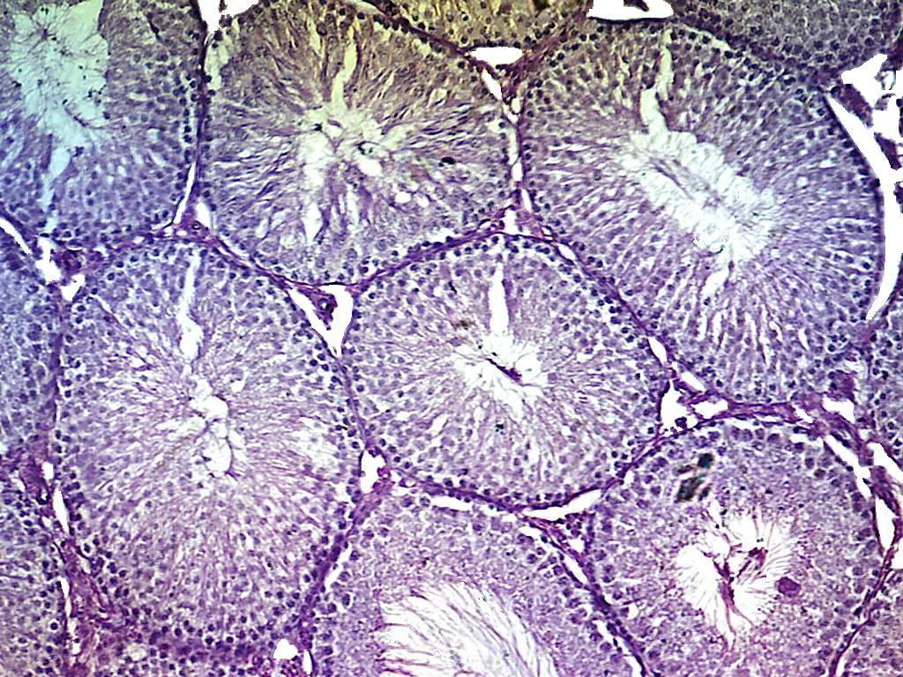
SE
S
LC
Figure (1): Photomicrograph of testis section from control group showing spermatogenic epithelium (SE) ( see normal spermatogenic cells with mature sperms (S)) and interstitial connective tissue with Leydig cells (LC) . (H & E, 10×).

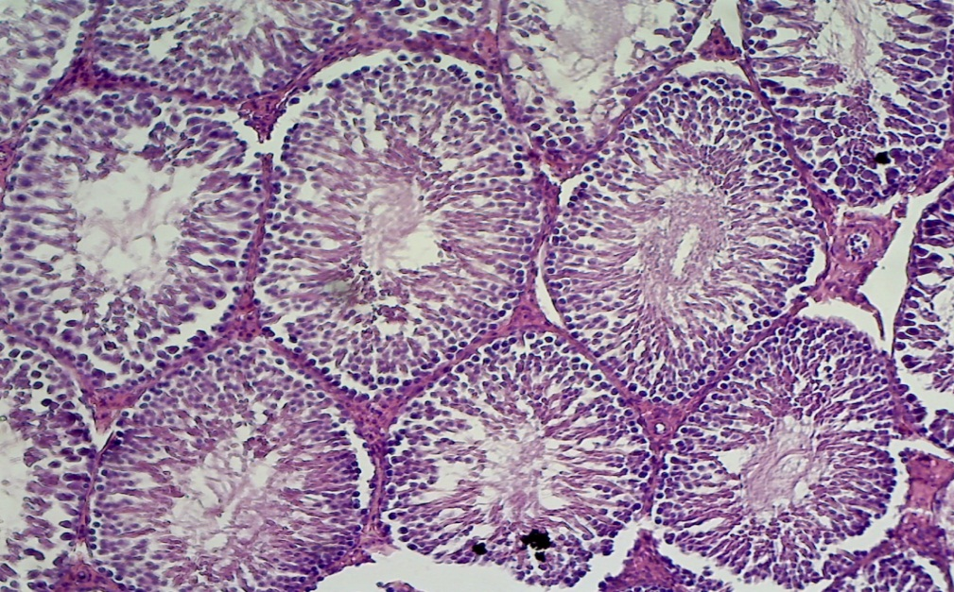
SC
OF
SB

Figure (2): Photomicrograph of testis section from Allicin -treated group showing the same histological feature of seminiferous tubules to control . Note: different stages of normal spermatogenic cells (SC) with presence of sperm bundles (SB), and few areas of oedematous fluid (OF). (H & E, 10×).

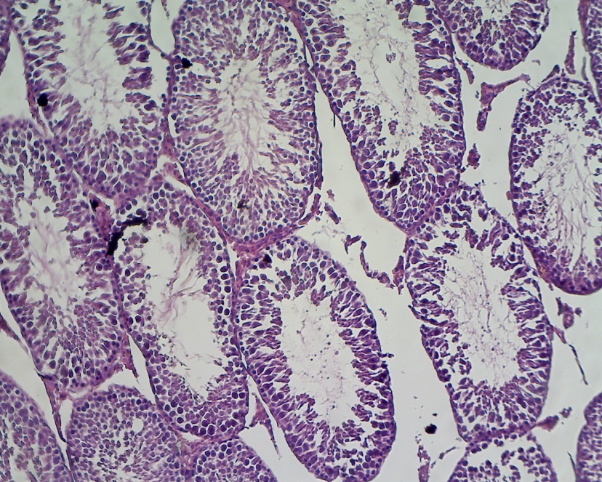
V
PN
S
IS
BM
D

Figure (3): Photomicrograph of testis section from ZnO -treated group showing alterations of the general architecture in some seminiferous tubules with inhibition of spermatogenesis. Note: degeneration (D) and disorganization of the germinal epithelium with occurrence of several large vacuoles (V), spermatogenesis arrest in some tubules and few fragmented spermatozoa (S) in the lumen, and irregular basement membrane (BM), most of spermatogonia had pyknotic nuclei (PN), marked increase in the intertubular spaces (IS). (H & E, 10×).

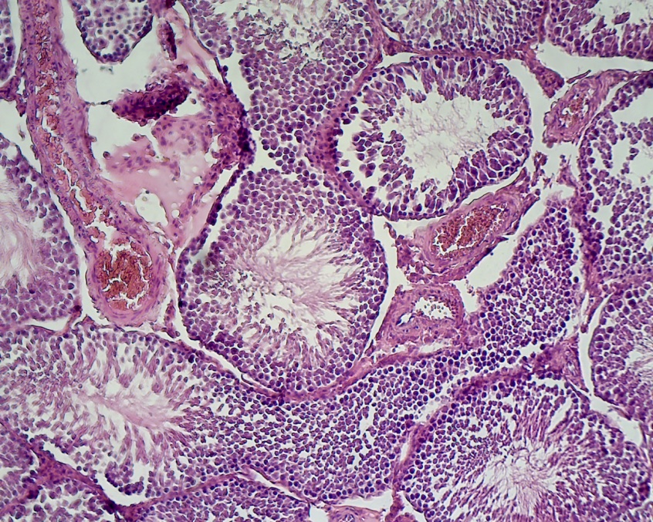
GC
PN
PN
H
CB

OF
D
Figure (4): Photomicrograph of testis section from ZnO -treated group showing sever lesion in some seminiferous tubules. Note: Degeneration (D) of spermatogenic cells and in the interstitium, Oedematous fluid (OF), congested blood vessels ( CB) , hyperplasia (H) of interstitial Leydig cells and formation of multinucleated giant cells (GC) with pyknotic nuclei (PN). (H & E, 10×).

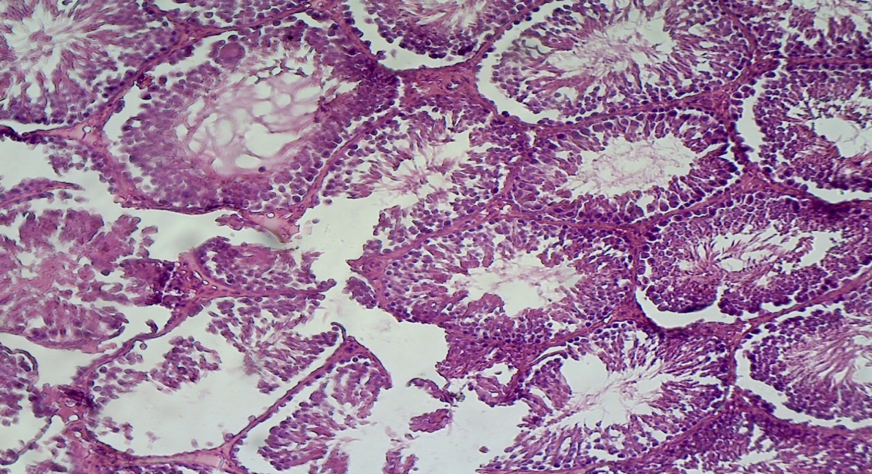
D
N
N
D
D
PN
Figure (5): Photomicrograph of testis section from ZnO-treated group showing serious deleterious effects on testicular structure. Note: degeneration (D) and necrosis (N) of germinal epithelium and spermatogenic arrest at various stages of spermatogenesis, and pyknotic nuclei (PN) of spermatogonia (H & E, 10×).

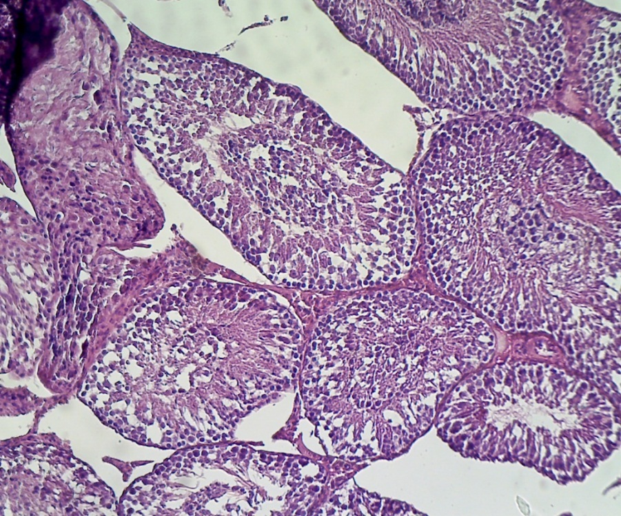
S
V
V

Figure (6): Photomicrograph of testis section from ZnO-treated group showing alterations of the general architecture in some seminiferous tubules. Note: disorganization of the germinal epithelium and occurrence of several large vacuoles (V), spermatogenesis arrest in some tubules and few fragmented spermatozoa (S) in the lumen.(H & E, 10×).
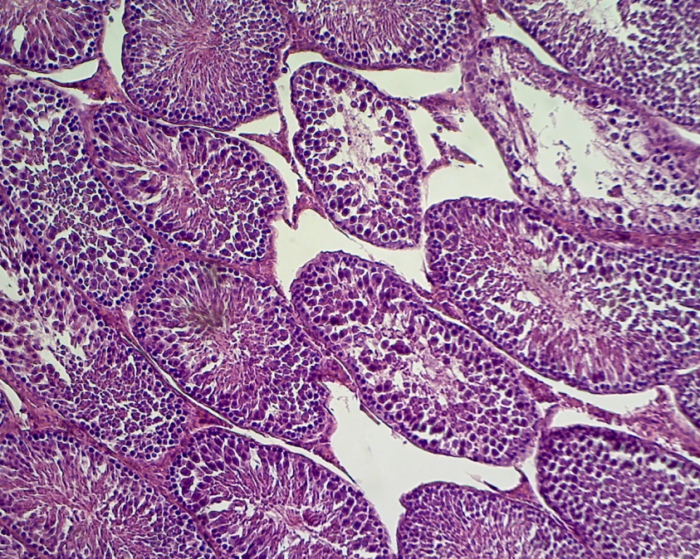
Figure (7): Photomicrograph of testis section from Allicin + ZnO -treated group showing marked enhancement histological feature of seminiferous tubules. Note: different stages of normal spermatogenic cells (SC) with presence of sperm bundles (SB) and arrest at the spermatid level in seminiferous tubule. (H & E, 10×).
PN
PN
SC
SB
SB
SB
SC
Figure (8): Photomicrograph of testis section from Allicin + ZnO -treated group showing successive stages of normal spermatogenic cells (SC) with presence of sperm bundles (SB) of seminiferous tubule and normal distribution of epithelial lining. (H & E, 10×).

Concerning histopathological examination of testes, the present results revealed that allicin (thiosulfanate) induced amelioration of testicular lesions (necrosis and degeneration) induced by ZnO in rats. also, the using of allicin alone at the concentration 50ppm will proved that is a good bioactive to protect the tissue from damage by using in this experiment, this is the purpose for treating with allicin alone of rats. The present results referred to the presence relationship between zinc oxide exposure and male reproductive toxicity, the microscopic examination of ZnO- treated rats revealed sever damages of histological testes this may be due to ZnO is responsible for increased oxidative stress (OS) and reactive oxygen species (ROS) which causing the damage of cellular lipids , proteins and DNA . Consequently, these alterations might be representing the cause of degeneration and necrosis that revealed in the histology of testis. Moreover, the cell membrane contains several highly unsaturated fatty acids which are easily attacked by free radicals leading to imitation lipid peroxidation which considered the rout for many pathological events (36). ROS are generated by metals, particularly transition metal ions can overcome the spin restriction of O2 and donate a single electron, giving raise to free radical species and chain reaction will be leading to inhibit protection mechanism against ROS, e.g., SOD, glutathione, in addition to other cytotoxic effects like DNA damage and inhibition of cellular respiration (37,38). In addition to, after releasing Zn²⁺ and O²⁻ will be to increase the local concentrations of metal ions and can disrupt metal cation cellular homeostasis. It has been reported that the oxidative stress can stimulate the increase of the intracellular Ca2+ concentration (39).In the present study, the microscopic examination of ZnO- treated rats revealed the occurrence of multinucleated giant cells of some tubules. Chinoy et al., (2005) (40) suggested that giant cells could be the result of faulty or failed chromosomal replication or cell division leading to arrest sperm formation.
The hyperplasia of interstitial Leydig cells can be as a compensatory attempt in order to face the decline which occurred in testosterone level. This may result in alteration of GnRH levels which may affect LH secretion from the anterior pituitary lobe that stimulates Leydig cells to proliferate as a compensatory mechanism (41) . Presence of interstitial edema and congestion may result from the oxidative damage of capillaries endothelial cells through interference with their membranes leading to increasing their permeability changes in capillary permeability and blood flow (42) . In addition to , one study has reported that the congestion in blood vessel walls is attributed to hypertension in the surface blood vessels (43) . On the basis of our findings , histological observations in the present study proved the excellent recovery of testes after allicin treatment , this may be due to the effect of allicin because of one of the beneficial biological properties of allicin components exhibit an antioxidant capacity and improved endogenous antioxidant the cellular antioxidant enzymes , (such as superoxide dismutase , catalase, glutathione peroxidase , etc) thereby protecting the cells against disease-causing oxidative damage on the contrary for using ZnO treatment. About the effects of Allium sativum on male reproductive system has not been clearly defined , some studies reported that feeding Allium sativum impaire testicular function in rats (44) and had a spermicidal effect on spermatozoa in vitro (45-49),Garlic causes increase in the percentage of empty seminiferous tubules , thereby altering spermatogenesis and reducing testosterone secretion (50,51) . On the hand, other researches demonstrated that Allium sativum had beneficial effects on the
defense system as well as enhancing testicular function and improved spermatogenesis in rats (52-55).Meanwhile, studies by Oi et. al., (56) found an increased testicular testosterone with garlic supplementation. Correlated with garlic use is the inhibition of Leydig
steroidogenic enzyme expression and Sertoli cell markers, which are capable of inducing apoptosis in testicular germ cells ( spermatocytes and spermatids) , characterized by increased levels of active Caspase 3 (CASP3)(57). The present study has established the ameliorating effect of allicin in the testicular structure and spermatogenesis process.

Conclusion
This study showed that allicin has alleviating effect and protective role in testicular tissue, in the condition of ZnO -induced oxidative stress. Moreover, it will be improved sexual efficiency of male rats.

References
1. Block, E. ( 1985). The chemistry of garlic and onion. Sci. Am;252:114-119.
2. Banerjee SK, Dinda AK, Manchanda SC and Maulik SK.( 2002). Chronic garlic administration protects rat heart against oxidative stress induced by ischemic reperfusion injury. BMC Pharmacology; 2:16.
3. Singh YP and Singh RA. (2010). Studies on organosulfur-functional active compounds in Allium sativum. Biofac, 36(4): 297-311.
4. Yun HM, Ban JO, Park KR, Lee CK, Jeong HS, Han SB and Hong JT. (2014). Potential therapeutic effects of functionally active compounds isolated from Allium sativum. Pharmacol Therp,; 142: 183-95.
5. Aqel MB, Gharaibah MN, Salhab AS. (1991). Direct relaxant effects of garlic juice on smooth and cardiac muscles. J Ethnopharmacol; 33:13-19.
6. Mahmoodi M, Hosseini-Zijoud SM, Hassanshahi GH, et al. (2011). The effects of consumption of raw garlic on serum lipid level, blood sugar and a number of effective hormones on lipid and sugar metabolism in hyperglycemic and/or hyperlipidemic individuals. Adv Biol Chem. 1(6): 29-33.
7. El Demerdash FM, Yousef MI, Abou El Naga NI. (2005). Biochemical study on the hypoglycemic effects of onion and garlic in alloxan-induced diabetic rats. Food Chem Toxicol, 43:57-63.
8. Martin N, Bardisa L, Pantojaa C, Vargas M, Quezaada P, Valenzuela J: (1994). Antiarrhythmic profile of a garlic dialysate assayed in dogs and isolated atrial preparations. J Ethanophrmacol 43:1-8.
9. Ried K, Frank OR, Stocks NP, Fakler P,Sullivan T. (2008). Effect of garlic on blood pressure: A systematic review and meta-analysis BMC Cardiovascular Disorders 8:13.
10. Milner, JA. (2001)."Mechanisms by which garlic and allyl sulfur compounds suppress carcinogen bioactivation. Garlic and carcinogenesis." Adv. Exp. Med. Biol 492: 69-81.
11. Duda G, Suliburska J and Pupek-Musialik D. (2008).Effects of short-term Allium sativum supplementation on lipid metabolism and antioxidant status in hypertensive adults. Pharmacol Res, 60(2): 163-70.
12. El-Khayam A, Peleg E, Grossman E, Shabtay Z and Sharabi Y. (2013). Effects of allicin on cardiovascular risk factors in spontaneously hypertensive rats. Israel Med Assoc J,;15(3): 170-3.
13. Kim I, Kim HR, Kim JH and Om AS. (2013).Beneficial effects of Allium sativum L. stem extract on lipid metabolism and antioxidant status in obese mice fed on a high-fat diet. J Sci Food Agric,. On line Doi: 10.1002/jsfa.6094; 2013 Feb 7.
14. Nasri H. (2013).Effect of Allium sativum extract on blood glucose level and lipid profile in normal and alloxan diabetic rabbits. Adv Clin Exp Med,; 22(3): 449-50.
15. Sohn DW, Han CH, Jung YS, Kim SI, Kim SW and Cho WH. (2009).Anti-inflammatory and antimicrobial effects of Allium sativum and synergistic effect between Allium sativum ciprofloxacin in chronic bacterial prostatitis rat model. Inter J Antimicrob Agents,; 34(3): 215-9.
16. Bayan L, Koulivand PH and Gorji A. (2014). Allium sativum: A review of potential therapeutic effects. Avicenna J Phytomed,; 4(1): 1-14.
17. Zhang CL, Zeng T, Zhao XL, Yu LH and Zhu ZP. (2012).; Protective effects of Allium sativum oil on hepatocarcinoma induced by N-nitrosodiethylamine in rats. Inter J Biol, 8(3): 363-74.
18. Chandrashekar PM, Prashanth K and Venkatesh YP. (2011).Isolation, structural elucidation and immunomodulatory activity of fructans from aged Allium sativum extract. Phytochem,; 72(3): 255-64.
19. Mirabeau TY and Samson ES. (2012). Effect of Allium cepa and Allium sativum on some immunological cells in rats. Afr J Tradit Complement Altern Med,; 9(3): 374-9.
20. Sankar K, Senthikumar GP, Sankar S and Bobby Z. (2013). Attenuation of oxidative stress, inflammation and insulin resistance by Allium sativum in fructose-fed male rats. J Clin Diagn Res,; 7(9): 1860-2.
21. Jeong JH, Jeong HR, Jo YN, Kim HJ and Shin JH. (2013). Ameliorating effects of aged Allium sativum extracts against Aβ-induced neurotoxicity and cognitive impairment. Complem Altern Med,; 13: 268-74.
22. Tugbobo OS, Oloyede OI and Adewale OB. (2014). Dietary protection by Allium sativum extract against lead induced oxidative stress and genetic birth defects. Oxid Antioxid Med Sci,; 3(1): 79-82.
23. Isidori AM, Pozza C, Gianfrilli D and Isidori A. (2006). Medical treatment to improve sperm quality. J Reprod Biomed,; 12: 704-14.
24. Mahgoub AA and El-Medany AH. (2001).Evaluation of chronic exposure of the male rat reproductive system to insecticide methomyl. Pharmacol Res,; 2:73-80.
25. Agbaje IM, Rogers DA, Mc-Vicar CM, Mc-Clure N, Atkinson AB, Mallidis C and Lewis SE. (2007). Insulin dependent diabetes mellitus: implications for male reproductive function. Hum Exper Reprod,; 22(7): 1871-7.
26. Abdulbari B, Al-Ansari AA, Zirie M and AL-Hamaq OA. (2009).Is male fertility associated with type 2 diabetes mellitus? Int J Urol Nephrol,; 41(4): 777-84.
27. Leong CT, D'Souza UJ, Iqbal M and Mustapha ZA. (2013). Lipid peroxidation and decline in antioxidant status as one of the toxicity measures of diazinon in the testis. Redox Rep,; 18(4): 155-64.
28. Jedlinska M, Bomba G, Jakubowski K, Rotkiewicz T, Jana B and Penkowski A. (2006).Impact ofoxidative stress and supplementation with vitamins E and C on testes morphology in rats. J Reprod,; 52: 203-9.
29. EL-Ashmawy VP, Saleh A and Salama OM: (2007).Effects of marjoram volatile oil and grape seed extract on ethanol toxicity in male rats. Basic Clin Pharmacol Toxicol,; (5): 320-7.
30. Ribeiro CT, Milomem R, De Souza DB, Costa WS, Sampaio FJ and Pereira-Sampaio MA. (2014). Effect of antioxidants on outcome of testicular torsion in rats of different ages. J Urol,; 191(5): 1578-84.
31. Maret, W. and Sandstead, H., (2006). Zinc requirements and the risks and benefits of Zinc supplementation. J. Trace. Elem. Med. Biol., 20: 3-18.
32. Luebke,R.W., Chen,D.H. and Luster, M.I., (2006). The comparative immunotoxicity of five selected compounds following development or adult exposure. J. Toxicol. Environ. Health PartB, 9. 1-26.
33. Luster, M .I. Mnuson, A.E. and Thomas, T. (1988). Method evalution development of testing Battery to assess chemical-induced.
34. Schiller, N.K. and McNamara, D.B. (1999). Balloon catheter vascular injury of the alloxan- induced diabetic rabbit: The role of insulin-like growth factor-1. Molecular and Cellular Biochemistry, 202:159-167.
35. Luna, L.G. (1968). Manual of histological staining method of the armed forces institute of pathology. 3rd ed.mcgraw. Hill book.Co .
36. Schinella, G.R.; Tournier, H.A.; Prieto, J.M.; Mordujovich de Buschiazzo, P. and Rios, J.L., (2002). Antioxidant activity of anti-inflammatory plant extracts. Life Sci., 70:1023-1033.
39. Xia, T.; Kovochich, M.; Liong, M.; Mädler, L.; Gilbert, B.; Shi, H.; Yeh, J.I.; Zink, J.I. and Nel, A.E. (2008).Comparison of the mechanism of toxicity of zinc oxide and cerium oxide nanoparticles based on dissolution and oxidative stress properties. ACS Nano, 2, 2121–2134.
40. Chinoy, N.J.; Sorathia, H.P. and Jhala, D.D .(2005). Fluoride+ aluminum induced toxicity in mice testis with giant cells and its reversal by vitamin C. International Society for Fluoride Research,38(2):109-114.
41. Mayyas, I.; Elbetieha, A. and Khamas, W.A. (2005). Evaluation of reproductive and fertility toxic potentials of aluminum chloride on adult male mice. Journal of animal and veterinary adnaances, 4 (2):224-233.
42. Maddocks, S. and Setchell, B.P. (1988).The composition of extracellular interstitial fluid collected with a push-pull cannula from the testes of adult rats. J Physiol., 407: 363–372.
43. Aoki, A. and Hoffer, A.P. (1978). Reexamination of the lesions in rat caused by cadmium. Bilo. Reprod., 18: 579-591.
44. Banerjee SK, Maulik M, Manchanda SC, Dinda AK, Das TK and Maulik SK. (2001).Garlic-induced alteration in rat liver and kidney morphology and associated changes in endogenous antioxidant status. Food and Chemical Toxicology;39(8):793-797.
56. Oi Y, Imafuku M, Shishido C, Kominato Y, Nishimura S, Iwai K. (2001).Garlic Supplementation Increases Testicular Testosterone and Decreases Plasma Corticosterone in Rats Fed a High Protein Diet. Journal of Nutrition;131:2150-2156.
52. Mistra HP, Fridovich I. The role of superoxide anion in the autoxidation of epinephrine and a simple assay for superoxide dismutase. J Biol Chem 1972;247(10):3170–3175.
54. Dixit VP and Joshi S. Effects of chronic administration of Allium sativum L on testicular function. Indian J Exp Biol, 1982; 20: 534-6.
55. Qian YX, Shen PJ, Xu RY, Liu GM and Yang HQ. Spermicidal effect in vitro by the active principle of Allium sativum . Contracep, 1986; 34: 295-302.
56. Chakrabarti K, Pal S and Bhattacharyya AK. Sperm immobilization activity by Allium sativum L and other plant extracts. Asian J Androl, 2003; 5: 131-5.
57. Hammami I, Nahdi A, Mauduit C, Benahmed M and Amri M. The inhibitory effects on adult male reproductive functions of crude Allium sativum L feeding. Asian J Androl, 2008; 10(4): 593-601.
58. Hammami I and El-May MV. Impact of Allium sativum feeding on male fertility.mAndrol, 2013; 45(4): 217-24.
59. Hammami I, Nahdi A, Atig F, Kouidhi W and Armi M. Effects of Allium sativum
fractions consumption on male reproductive functions. J Med Food, 2013; 16(1):82-7.
60. Kasuga S, Uda N, Kyo E, Ushijima M and Morihara N. Pharmacologic activities of aged Allium sativum extract in comparison with other Allium sativum preparations. J Nutri, 2001; 131: 1080-4.
61. Ola-Mudathir KF, Suru SM, Fafunso MA, Obioha UE and Faremi TY. Protective roles of onion and Allium sativum extracts on cadmium-induced changes in sperm characteristics and testicular oxidative damage in rats. Food Chem Toxicol, 2008; 46(12): 3604-11.
62. Lee SC, Hwang SY, Kim SW and Kim SK. Ethanol extract of Allium sativum attenuates testicular and liver toxicity induced by 2, 3, 7, 8-tetrachloro- dibenzo-p-dioxin in rats. J Med Food, 2009; 12(1): 93-9.
63. Ponnusamy M and Pari L. Protective role of diallyl tetrasulfide on cadmium-induced testicular damage in adult rats: a biochemical and histological study. Toxicol Ind Health, 2011; 27(5): 407-16.

